University of Vocational Technology
Faculty of Information Technology
B. Tech in Software and Intelligent Systems., Computer Networks and Cloud Security, Web and Creative Media
2024/2025–B1 Year I Semester I (SI)
Examination Timetable – Semester 1

# | Module Code | Module Tittle | Date | Time | Venue
 | IT103012 | Mathematics for IT I | 19.12.2025 | 9.00 am- 12.00pm | Exam Hall
 | IT104072 | Internet Technologies | 20 .12.2025 | 9.00 am- 12.00pm | Exam Hall
 | IT103082 | English Language Communication Skills for IT I | 21.12.2025 | 9.00 am- 12.00pm | Exam Hall
 | IT103062 | Database Design | 26.12.2025 | 9.00 am- 12.00pm | Exam Hall
 | IT104022 | Computer Programming | 27.12.2025 | 1.00 am- 4.00pm | Exam Hall
 | IT104052 | Data Communication and Networks | 28.12.2025 | 9.00 am- 12.00pm | Exam Hall
 | IT103042 | Digital Electronics | 02.01.2026 | 9.00 am- 12.00pm | Exam Hall
 | IT102030 | Information Systems | 04.01.2026 | 9.00 am- 12.00pm | Exam Hall

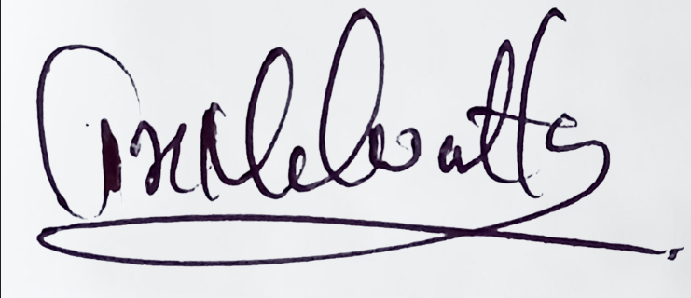
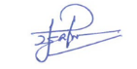

Mr. P.H.S.S. Wijayarathna Eng. (Ms.)T.K.Malwatta
Senior Lecturer/Coordinator S1 Dean- Faculty of Information Technology

University of Vocational Technology
Faculty of Information Technology
B. Tech in Software Technology, Network Technology, Multimedia and Web Technology
Repeat Examination Timetable – Semester 1

# | Module Code | Module Tittle | Date | Time | Venue
 | IT103011 | Mathematics for ICT I | 19.12.2025 | 9.00 am- 12.00pm | Exam Hall
 | IT104071 | Internet Technologies | 20 .12.2025 | 9.00 am- 12.00pm | Exam Hall
 | LS103101 | Communication Skills in English I | 21.12.2025 | 9.00 am- 12.00pm | Exam Hall
 | IT103061 | Database Design | 26.12.2025 | 9.00 am- 12.00pm | Exam Hall
 | IT104021 | Computer Programming | 27.12.2025 | 1.00 am- 4.00pm | Exam Hall
 | IT103051 | Data Communication and Networks | 28.12.2025 | 9.00 am- 12.00pm | Exam Hall
 | IT103041 | Digital Electronics | 01.02.2026 | 9.00 am- 12.00pm | Exam Hall
 | IT104031 | Software Development Practices | 01.04.2026 | 9.00 am- 12.00pm | Exam Hall

Mr. P.H.S.S. Wijayarathna Eng. (Ms.)T.K.Malwatta
Senior Lecturer/Coordinator S1 Dean- Faculty of Information Technology

