**B.Tech. in Industrial Management Technology**

**Department of Industrial Management**

**Faculty of Industrial Technology**

**2020/21- Y3 SII - Examination Timetable (B1& B2)**

|  |  |  |  |  |
| --- | --- | --- | --- | --- |
| **Date** | **Time** | **Module code** | **Module title** | **Venue** |
| 15/12/2024 | 9.00 am-12.00 pm | MS60402 | Occupational Health & Safety | CR 16 (OB) |
| 16/12/2024 | 9.00 am-12.00 pm | MS60301 | Plant Layout & Materials Handling | CR 16 (OB) |
| 21/12/2024 | 9.00 am-12.00 pm | MS60406 | Work Study & Ergonomics | CR 16 (OB) |
| 22/12/2024 | 9.00 am-12.00 pm | MS60403 | International Trade & Export Marketing | CR 16 (OB) |
| 28/12/2024 | 1.00 pm- 4.00 pm | MS60304 | Innovation Management | CR 16 (OB) |
| 29/12/2024 | 9.00 am-12.00 pm | MS60305 | Environmental Management and Cleaner Production | CR 16 (OB) |

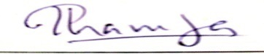 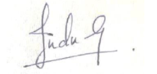

**T.R. Vidanapathirane W.A.I.M.Gunaskeara**

**Coordinator- Year 3 Head – Department of Industrial Management**

**Venues will be notified later**