Department of Industrial Management
B.Tech in Hotel Management Examinations (March – April 2025)
Module | Date | Time | Venue
Introduction to Hospitality and Tourism Industry  HM30601 | 23/03/25 | 1.00 pm – 4.00 pm | CR 13 (OB)
Lodging Operation Management  HM30602 | 29/03/25 | 1.00 pm – 4.00 pm | CR 13 (OB)
Food & Beverage Management  HM30603 | 30/03/25 | 9.00 am – 12.00 noon | Exam Hall
Hospitality Managerial Accounting  HM30604 | 05/04/25 | 9.00 am – 12.00 noon | Exam Hall
Sri Lankan History, Culture and Society  HM30605 | 06/04/25 | 9.00 am – 12.00 noon | Exam Hall
2022/23 B2 Y2 SI

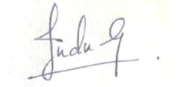

Head of the Department

