**B.Tech. in Industrial Management Technology**

**2023/2024- Year I - Semester I - Examination Time Table (B1& B2)**

**Department of Industrial Management**

|  |  |  |  |  |  |
| --- | --- | --- | --- | --- | --- |
| **No** | **Date** | **Time** | **Module code** | **Module title** | **VENUE** |
| 1 | 08/12/2024 | 9.00 am - 12.00 pm | MS10401 | Management Theory & Practice | CR 16 |
| 2 | 16/12/2024 | 1.00 pm - 4.00 pm | MS10307 | Business Statistics-1 | Exam Hall |
| 3 | 22/12/20224 | 1.00 pm - 4.00 pm | MS10404 | Introduction to Accounting | CR 16 |
| 4 | 28/12/2024 | 9.00 am-12.00 pm | MS10406 | Information Technology for Managers | Exam Hall |
| 5 | 29/12/2024 | 1.00 pm - 4.00 pm | MS10408 | Introduction to Economics | Exam Hall |
| 6 | 04/01/2025 | 9.00 am-12.00 pm | MS10402 | Mathematics for Management | Exam Hall |
| 7 | 05/01/2025 | 9.00a.m – 12.00pm | MS10405 | Marketing Management | Exam Hall |
| 8 | Common module. Date to be decided by the Faculty of Education. | | LS103101 | Communication Skills- I |  |

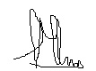 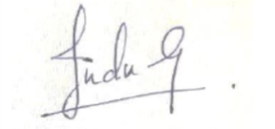

**M.H.Methmini Tharanga Indrachapa Gunasekara**

**IM Coordinator- Year I Semester I Head – Department of Industrial Management**