**Faculty of Industrial Technology**

**B.Tech in Industrial Management Technology**

**Academic Year: 2022/23 Batch: B1 &B2**

|  |  |  |  |
| --- | --- | --- | --- |
| **Module Title & Code** | **date** | **Time** | **Venue** |
| MS40605  Computer-Aided Design and Manufacturing | 13.09.2025 | 9.00-12.00 | Exam Hall |
| MS40406  Research Methods | 14.09.2025 | 9.00-12.00 | Exam Hall |
| MS 40407  Management of Technology | 20.09.2025 | 9.00-12.00 | Exam Hall |
| MS40507  Quality Control Techniques | 21.09.2025 | 9.00-12.00 | CR 16 (OB) |
| Ms40402 Electronic Commerce & Web Technology | 27.09.2025 | 13.00-16.00 | CR 16 (OB) |
| MS40403  Logistic and Supply Chain Management | 28.09.2025 | 13.00-16.00 | CR 16 (OB) |
| MS40405  Financial Management | 04.10.2025 | 13.00-16.00 | CR 16 (OB) |

**Examination: Semester 4(Physical mode)**

Ms. Thamara Jayasekara 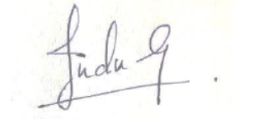Ms. Indrachapa Gunasekara

Coordinator Year II ……………………………………………………….

Head of the Department of Industrial Management